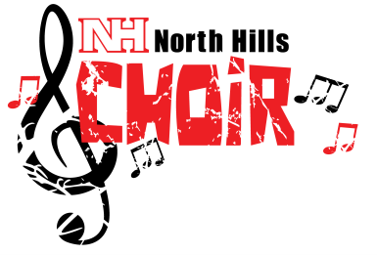
7th & 8th Grade Choirs
Important information!

MANDATORY REHEARSAL – Monday 5/22/17
8th Grade: Homeroom until 4:00pm
7th Grade: 4:00pm – 5:00pm
(7th graders – You may sit QUIETLY and do homework in the auditorium while 8th grade rehearses, or you may return to school by 4pm)

**This rehearsal is worth a 25 point GRADE for all students. If you are removed from rehearsal because of bad behavior, you will receive a ZERO for this grade!**

MANDATORY CONCERT
Tuesday, May 23, 2017
6:30pm – Report to Cafeteria - Do NOT be late!
7:00pm – Performance
in North Hills Middle School Auditorium
(Parents and families encouraged to attend!)
**This Concert is worth a 50 point grade!!**

DRESS CODE for CONCERT – See other side!! ->>

The Concert and all rehearsals are mandatory for each student or member. Illness, death in the family, or out of town trips would be considered excused absences. If any of these occur, a parent should call Mrs. Triscila or send a written note prior to the concert. I appreciate your cooperation and look forward to you hearing your children sing! If you have questions or concerns, please contact me!

Mrs. Triscila triscilar@nhsd.net 412-318-1450 ext. 4561

FORMAL CONCERT DRESS CODE

Girls

♬Black skirt (at least knee length)
OR
♬Black DRESS pants

♬White shirt/blouse WITH sleeves

♬Black shoes (flat or low heel)

The following are NOT acceptable:

NO Short Skirts!
NO leggings!
NO black jeans!

Boys

♫Black dress pants/slacks

♪White long-sleeve dress shirt

♪Tie (any color)

♪Black shoes (black socks)

The above Dress Code will be strictly enforced for the Concert! For any dress code violations, 10 or more points will be deducted from the student’s concert grade!

If you do not own any of the above items, please BORROW them or buy something inexpensive!! Our goal is NOT for you to spend a lot of money! The Band and Orchestra students at the middle school have very similar dress codes for their concerts – borrow from one of your friends for the evening!!

