North Hills Middle School
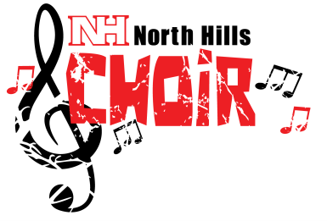
Concert Choir
2015-2016

BARITONES
(Monday)

Travis Coaston - 8
Jesse Crownover – 8
Loran Ferrell - 7
Zach Ford – 7
Curtis Foskey – 7
Damon Goettel - 7
Colin Kozlowski – 7
Joshua Kubala - 7
Ethan Marker – 7
Logan Marshalek - 8
Grant Mumper – 8
Jacob Smith - 8
Brennen Topnick - 8

SOPRANOS
(Wednesdays)

Anastasia Aggelou – 7
Jaelyn Aguglia-Laird– 8
Angelina Asturi - 8
Kasia Bauer – 8
Julia Carney - 7
Mandy Doan – 7
Chelsi Egan – 8
Tyjae Good - 8
Celeste Hartle – 8
Morgan Hezlep – 8
Sydney Kissner - 7
Bella Kunz – 8
Kaylee Kleinsmith – 8
Kersten Lubbert - 7
Amy Marciniak – 7
Ryleigh Murphy - 7
Mackensie Nash – 8
Chiara Ocasio - 7
Milaina Roach – 7
Chloe Salopek – 7
Mady Siatkowsky – 8
Kayla Watson - 8
Alayna White – 7
Megan Wurster - 8

ALTOS
(Fridays)

Abby Begler - 8
Chloe Benko – 8
Lexi Bruner - 8
Sofia Caloiero - 8
Katie Emmons - 8
Katie Eshenbaugh – 8
Ellie Fleischer - 7
Jane Fusco – 8
Lauryn Graham - 8
Alexis Green – 8
Emily Geyer – 8
Alayna Hibbard - 7
Grace Lawrence – 7
Adrianne Lipscomb - 8
Rose McIntyre - 8
Abby Mulrow – 8
Danielle Murray - 7
Morgan Nolan - 7
Lydia Ohm – 7
Lexi Palmer – 7
Nina Topich - 8
Kaliy Trembulak – 7
Acacia Uechi – 7
Julianna West - 8
Laiken Young - 8

